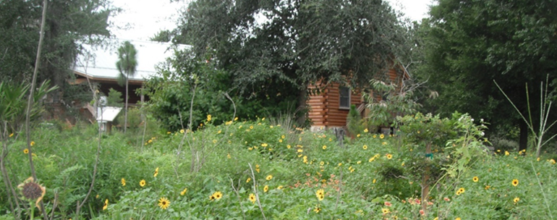 | Osprey  Observer  Summer 2021
EDUCATING . CONSERVING . RESTORING

Message from the President
by Jim Peterson

It’s summer, and it’s hot outside, but it is still a great time to go out and enjoy nature. I just recommend starting your adventure early in the morning when it is cooler and before the afternoon storms begin. Summer rains are here, and the plants at the Preserve are green with happiness after enduring the many weeks of very little rainfall at the end of our dry season.
I want thank all of the staff, volunteers, supporters, and visitors who helped us keep the Preserve open and functioning through the pandemic. The hard work from the Preserve staff and volunteers coupled with financial assistance from the town, county, members, visitors, and foundations allowed us to function through an extraordinary time.
The Preserve is still following its mission to educate, preserve, and restore. The restoration team has continued to work tirelessly planting and maintaining our restoration areas. The education staff is holding camps, and our school visits are starting again. We hold regular Yoga classes on the Serenity Porch, and Blue Hike adventures are scheduled through the winter months. Our goal is always to offer eco-friendly events and opportunities for exercise and nature hike experiences. We only ask that everyone leave no trace and respect the plants and animals at the Preserve.
I am excited to announce that two private foundations that have supported Oakland Nature Preserve in the past are teaming up to fund additional bathrooms at the Preserve. The additional bathrooms will assist us with our ability to handle classes and events at our Jim Thomas Environmental Education building. We also will be working with the Town of Oakland to connect our bathrooms to city sewer, which is better for the environment.
Lately the Florida Manatee has been in the news because of the surge in deaths this year. The deaths are a combination of health issues from lack of sea grass for them to eat and boat impacts. There are several manatees in the Harris Chain of Lakes, and two have even been observed in Lake Apopka. Several environmental groups are worried that boaters in the Harris Chain are not used to having manatees in our lakes and will not be looking for them while boating. Manatees should normally be found in the shallower areas of the lakes, feeding on submersed plants growing along the perimeter. If you see manatees while boating, please reduce your speed to an idle and allow the manatee to get a safe distance away before resuming your speed. Please contact the Fish and Wildlife hotline if you find an injured or distressed manatee. Please cherish and respect these unusual mammals if you are lucky enough to encounter them in your adventures.
Please continue to check our website for upcoming events. Summer adventure camps are currently underway; monthly Blue Hikes start again in September; Yoga classes are held most Saturdays; our Open House this year is scheduled for September 25, and we plan to hold our Pumpkin Glow event again this year in October.
Thanks for your support.
Be sure to follow us on Facebook for Preserve news and events!

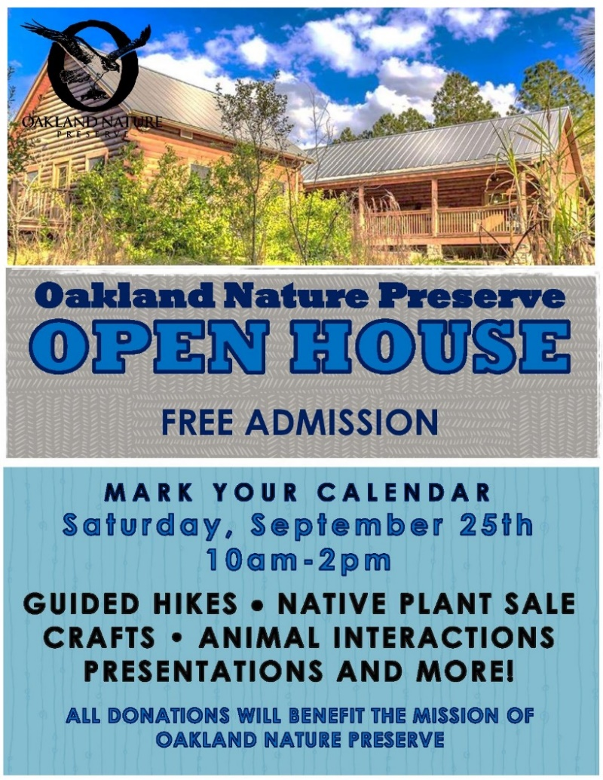
Easy Ways To Give

Upcoming Events

- Senior Strides – Thursdays at 9:30
- Yoga at the Lake – Saturdays at 9:30

- Sept 10 – FMNP Uplands Begins
- Sept 18 – Science Saturday, Magical World of Hummingbirds (Noah’s Notes)
- Sept 25 – ONP Open House
- Oct 16 – Science Saturday, Raccoons-Mischievous & Misunderstood (Noah’s Notes)
- Oct 28 – Jock-o’-lantern drop-off begins!
- Oct 29 – Pumpkin Glow 2021!
- Oct 30 – Pumpkin Glow 2021!

CARS is a 501(c)(3) nonprofit organization based out of San Diego, California. Today, CARS is partnered with over 3,500 nonprofits with the vision of expanding fundraising efforts so that they can continue to provide additional revenue to these amazing nonprofit organizations. (careasy.org/about)
Visit www.OaklandNaturePreserve.org/donate for more ways to give.

Who’s on the Board of Directors?

The Board of Directors for Oakland Nature Preserve deserve some recognition for their volunteer service to keep this beautiful place preserved. They have been elected for their interest in Florida’s natural environment. Some are ex officio from the Town of Oakland. Some were regular volunteers in some other capacity at the Preserve before being asked to be on the board. Some were asked to serve because of some expertise that the Preserve needed.
A few have already been honored for their service with a plaque that hangs on the wall of the porch, including:
Don and Phyllis Hickman, who were board members for many years.

John and Nancy Deam for whom the ecotone garden next to the entrance to the boardwalk was named. They were board members for many years and helped get the Preserve off the ground. They took photographs, preserved the history, and produced the newsletter.
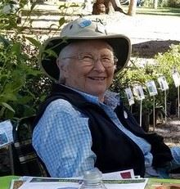
Peggy Lantz is a current board member, asked by Jim Thomas to come on board in 2000. She is a writer and editor who wrote articles about the Preserve for the West Orange Times. Twenty of those articles were gathered into a booklet, Introducing Oakland Nature Preserve, that the Preserve sold to visitors. Peggy is responsible for getting the Florida Master Naturalist classes offered at the Preserve, and brought Jackie Rolly on board as her co-instructor. She continues to edit many of the articles in ONP’s quarterly newsletter, The Osprey Observer, and assists with special events. Peggy has written many articles and several books about Florida’s environment, and invites you to check out her new website and read her blogs. www.peggysiaslantz.com.

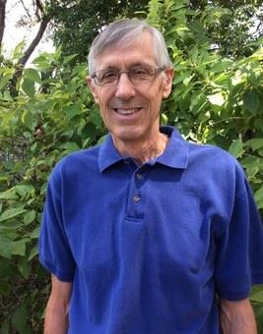
Jim Helmers - What better qualifications can you have than Jim’s to serve on the board of directors for Oakland Nature Preserve. He's a Forest Land Manager, a Master Tree Farmer and was named to the top 100 Florida Forest Landowners last year. He’s also a retired emergency doctor, in case anyone gets hurt while he’s at the Preserve.

Jim also did native plant propagation at Jim Thomas's Biosphere Nursery for 10 years before becoming a volunteer at ONP in 2011 and has been on the board of directors since 2013. He’s masterminding the restoration of the Red Trail, which was once a 10-acre sand pine forest. He oversaw the removal of the sand pines and the prescribed burns, and is now planting longleaf pines and understory. As the sandhill habitat returns, he is watching the return of gopher tortoises, bobcats, raccoons, coachwhip snakes, and other wildlife that are much happier with the renewed sandhill habitat than they were with the sandpine monoculture. The increased diversity of birds, monitored by Orange Audubon Society, has been remarkable, including Chipping Sparrows, Chimney Swifts, a Short-tailed Hawk, Pileated Woodpeckers, Great Crested Flycatchers, Eastern Bluebirds, Northern Parulas, and Cedar Waxwings.

Jim and Mary's grandchildren go to ONP summer camp, and he also helps with maintenance and fundraising and grants and serves on the restoration committee.

Visit the www.OaklandNaturePreserve.org/our-board for BOD information. Learn about other members in the
upcoming Osprey Observer.

New Restrooms Coming to ONP!

Please be aware that the porch of the Jim Thomas Education Center will be expanding to add restrooms and sinks to the facility. Construction will begin mid-July and will continue into September. There will be no access to the Pioneer Garden area during this time.

This project was made possible by grants from 2 local foundations and the Town of Oakland. Along with the additional facilities the Preserve will be able to hook into the town’s sewer system.
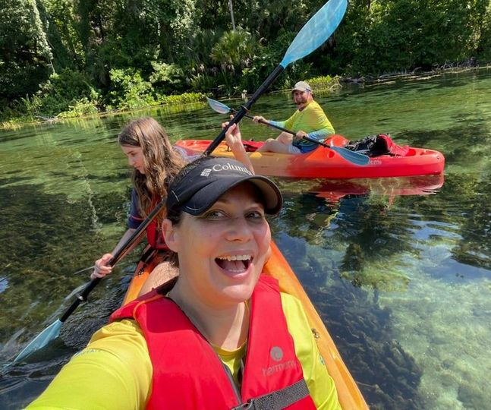
Blue Hike Paddle Tours
ONP is delighted to announce upcoming Fall dates of our Blue Hike Paddle Tours. This special program is made possible by generous support from Duke Energy. ONP’s Blue Hikes show paddlers the natural beauty, history, plants, and animals of Lake Apopka, along with an interpretative telling of the restoration progress of the lake. They have since diversified to include several other locations, highlighting features and importance of many other central Florida’s waterways. Upcoming Blue Hikes include:
- September 18 – Dora Canal
- October 16 – Bugg Spring Run
- November 13 –Smith Island
- December 11 – Wekiva Falls, Wekiva River

Registration for Fall paddles will open in August
For more information and registration visit www.OaklandNaturePreserve.org/blue-hike
We Dig Our Volunteers! By Nicole O’Brien
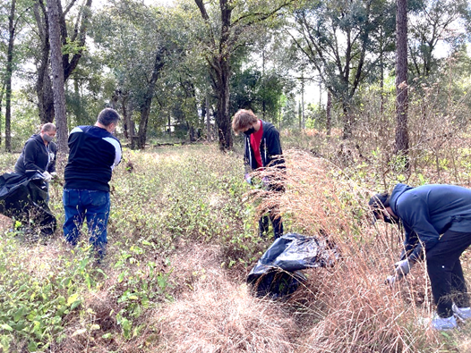
Volunteers collectively contributed 6000 hours to help the Preserve with our mission this past fiscal year. We have had an increase in volunteers who assist with education – Docents in the museum showcase our exhibits and Eco-Interpreters on our porch greet visitors with artifacts and activities. We have had volunteers assist with maintenance duties – repairing fences and other small structures, keeping the trails and boardwalk clear of debris, cleaning much more.
Many volunteer hours furthered habitat restoration – weeding out invasive plants, planting, watering. Volunteers aided us with the execution of some new events – Pumpkin Glow, Pours at the Preserve, Bubbly on the Boardwalk, and Plant Sales.
Every hour volunteers invest here helps the Preserve provide more opportunities for our community to explore, learn about, and develop an appreciation for the environment. We are extremely grateful!
More information on all of our volunteer opportunities can be found at https://oaklandnaturePreserve.org/Volunteer

Ambassador Animal Updates by Nicole O’Brien
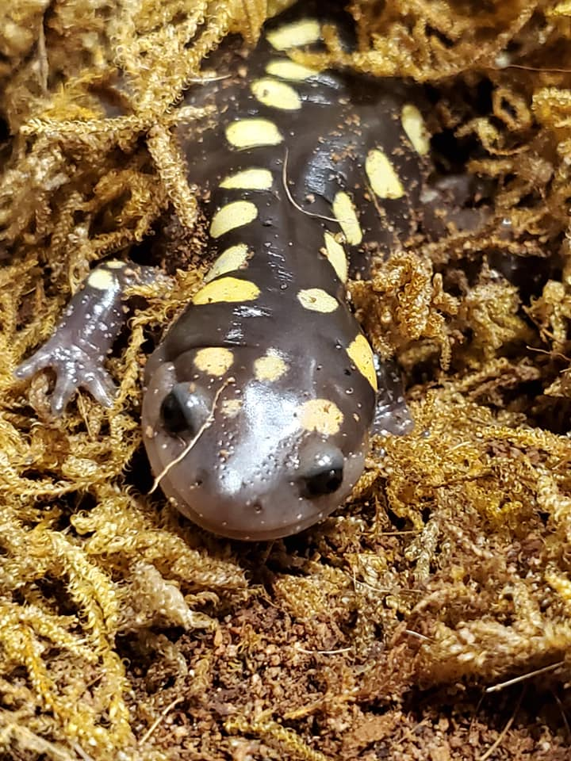

Did you know that you also have the ability to Adopt an Ambassador – donations help provide for care of our ambassadors. Adopters receive a personalized certificate of adoption via email or you can make your adoption even more special by spending time with an ambassador reptile and create beautiful and unique art to take home. This memorable encounter includes all supplies to create your personalized art with your choice of a turtle or snake as your artistic partner.
https://oaklandnaturepreserve.wildapricot.org/Adopt

Visit the ONP Online T-shirt Store
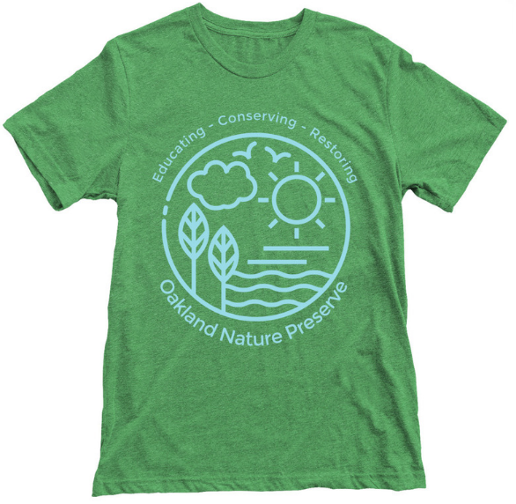
Did you know that your Preserve has an online
t-shirt shop? Well we do!

We are adding new shirt designs for your enjoyment. Do you have a shirt them that you think would be a great addition? Let us know.
All proceeds fund the mission of Oakland Nature Preserve.
Visit https://www.bonfire.com/store/oakland-nature-preserve/

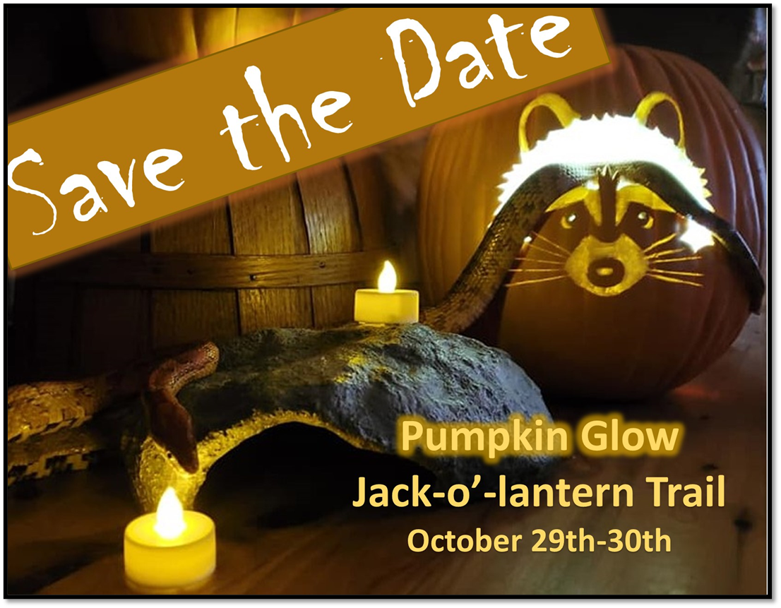
What’s In Bloom
by Denise Byrne

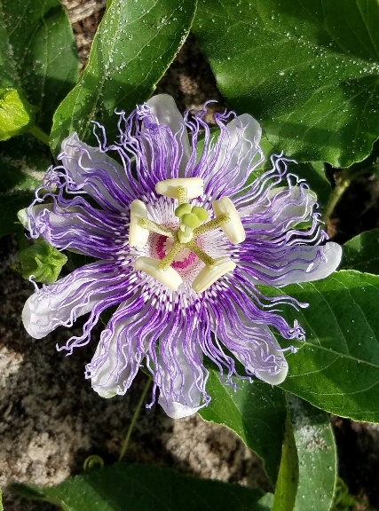
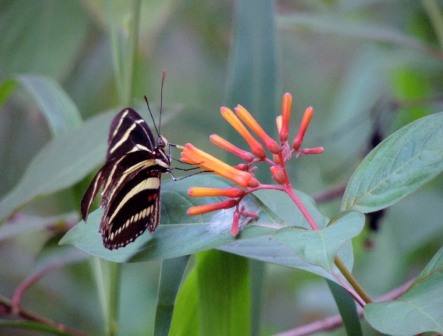
There is a lot in bloom right now in the uplands at the Preserve:
Mimosa strigillosa
Passiflora incarnata
Hamelia patens
• Mimosa/Powderpuff, Mimosa strigillosa, is in bloom around the Education Center and Butterfly Gardens. The leaves fold up when touched, giving it another common name: “sensitive mimosa”. An important cover species, this species of mimosa provides many ecological functions: the seeds are eaten by quail, songbirds, and Gopher Tortoises; foliage is eaten by gopher tortoises and wild turkeys; it is pollinated by bees and is the larval host of Little Sulfur Butterfly.
• Purple Passionflower, Passiflora incarnata, is also known as maypop and passionvine. It is a deciduous vine that climbs by tendrils and spreads rapidly with underground runners. It is a larval host plant for numerous butterflies including Gulf Fritillary Butterfly, Agraulis vanillae, Zebra Longwing, Heliconius charithonia, Variegated fritillary, Euptoieta claudia, and the Banded Hairstreak Satyrium calanus. Young tendrils are eaten by Wild Turkey. The fruits are edible by mammals, including humans. At the Preserve you will see Purple Passionflower in bloom on the Red and Orange Trails.
• Firebush, Hamelia patens, in the Bird, Butterfly and Dean Gardens, is a wildlife attractant for a variety of butterflies, hummingbirds, wasps, and halictid bees. Bees are considered the principle pollinator because they crawl down the floral tube to access nectar. The leaves are food for the Pluto Sphinx and Nessus Sphinx moths.
• Turk’s Cap Mallow, Malvaviscus arboreus, related to hibiscus, has petals that are folded spirally and only partially unfurl to form a turban-shaped flower, to encourage pollination by hummingbirds. You will see Turk’s Cap Mallow around the Education Center, the luscious flowers are a favorite of our resident Gopher Tortoises.
In the wetlands you will see:
• Buttonbush, Cephalanthus occidentalis, which attracts butterflies, bees, and hummingbirds. The seeds are a source of food for ducks and shorebirds.
• Elderberry, Sambucus canadensis, is a member of the honeysuckle family. Its fruits (black berries) are popular with birds, and the flowers attract a variety of pollinators.
• Grassy Arrowhead, Sagittaria graminea, attracts lots of pollinators, and its seeds are eaten by birds.
• Pickerelweed, Pontederia cordata, has vibrant purple flowers that attract a variety of butterflies, wasps, and bees. One species of solitary ground-nesting bee, Dufourea novaeangliae, only uses Pickerelweed to gather nectar and pollen. Small seeds are produced that are food for a variety of animals, including ducks and other waterfowl. Deer and geese will munch on leaves and roots of the plant, while fish, birds, insects, amphibians, reptiles, and other critters use pickerelweed as cover. Dense mats of growth provide excellent cover for pickerel fish, which feed on the insects that are attracted to the flowers of this plant (giving the plant its common name). They don’t live in Lake Apopka, but manatees also eat pickerelweed!
• Scarlet Hibiscus, Hibiscus coccineus, produces beautiful blooms that provide nectar to a variety of pollinators including the specialist Rose Mallow Bee and Ruby Throated Hummingbirds. This plant also hosts caterpillars of gray hairstreak, painted lady butterflies and several moths and skippers.
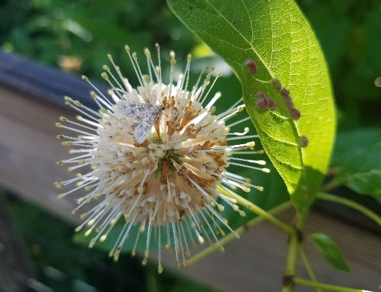
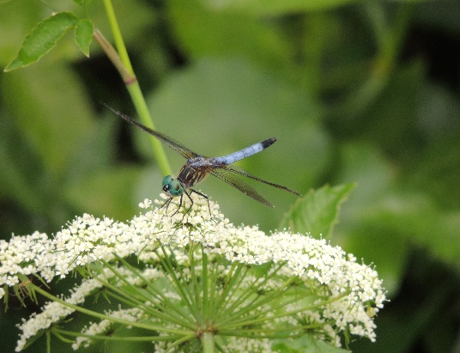
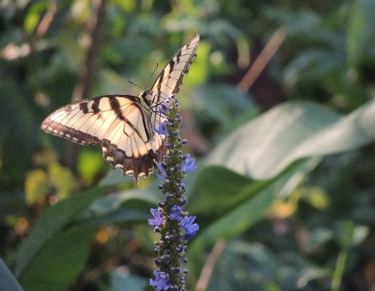
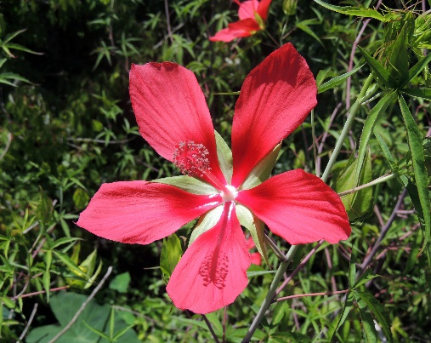
Sambucus graminea
Cephalanthus occidentalis
Hibiscus coccineus
Pontederia cordata

Ways you can help your Preserve:
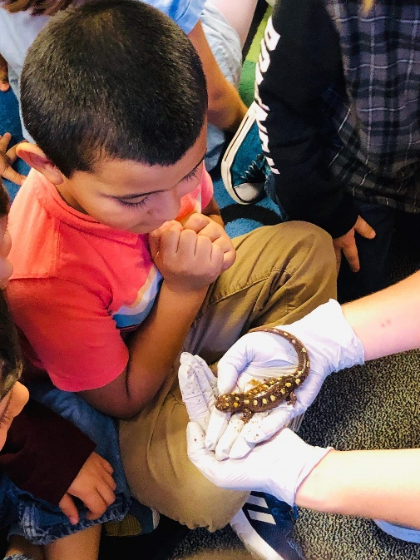
• Volunteer your time.
• Participate in programs.
• Adopt an ONP Ambassador animal.
• Donate money.
• Donate a vehicle through the CARS program.

Visit www.OaklandNaturePreserve.org/donate
for more information
Who is on the Prowl at Oakland Nature Preserve?
Our Trail Cameras are staying very active photographing resident bobcats, coyotes, raccoons, opossums, and rabbits in the uplands. They snapped a bobcat family recently, along with owls, and a Whip-poor-will (a first on the cameras at ONP!). Check out the album in the museum or our Facebook page for the most recent photos. A big thank you to our wonderful volunteer Gloria, who keeps the kiosk on the Orange Trail updated with recent photos too!
